Experiment 02
Semantic Web using Apache TinkerPop
1.Semantic Web
Data is stored with meaning and relationships
Instead of tables, we use a graph:
• Nodes (Vertices) → Things (people, software)
• Edges → Relationships (created, knows)
This is why it’s called Semantic (meaningful).

2.What is Apache TinkerPop?
Apache TinkerPop is:
• A graph computing framework
• Used to create, store, and query graph data
It does NOT store tables.
It stores:
• Vertices (nodes)
• Edges (relationships)

3.What is Gremlin?
Gremlin is:
• A graph query language
• Similar to SQL, but for graphs
SQL Gremlin
SELECT g.V()
WHERE has()
JOIN out(), in()
So:
Gremlin = SQL for graph databases

STEP 0 : Installation of Tinkerpop
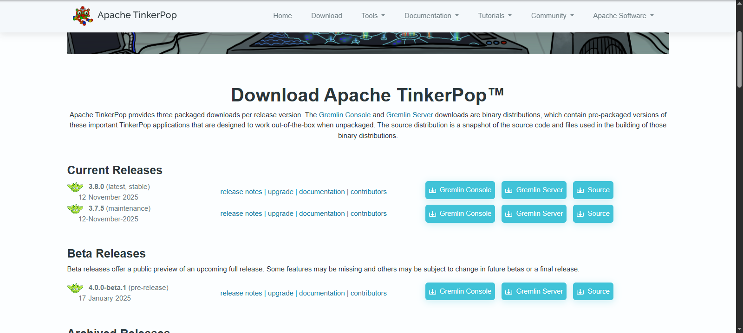
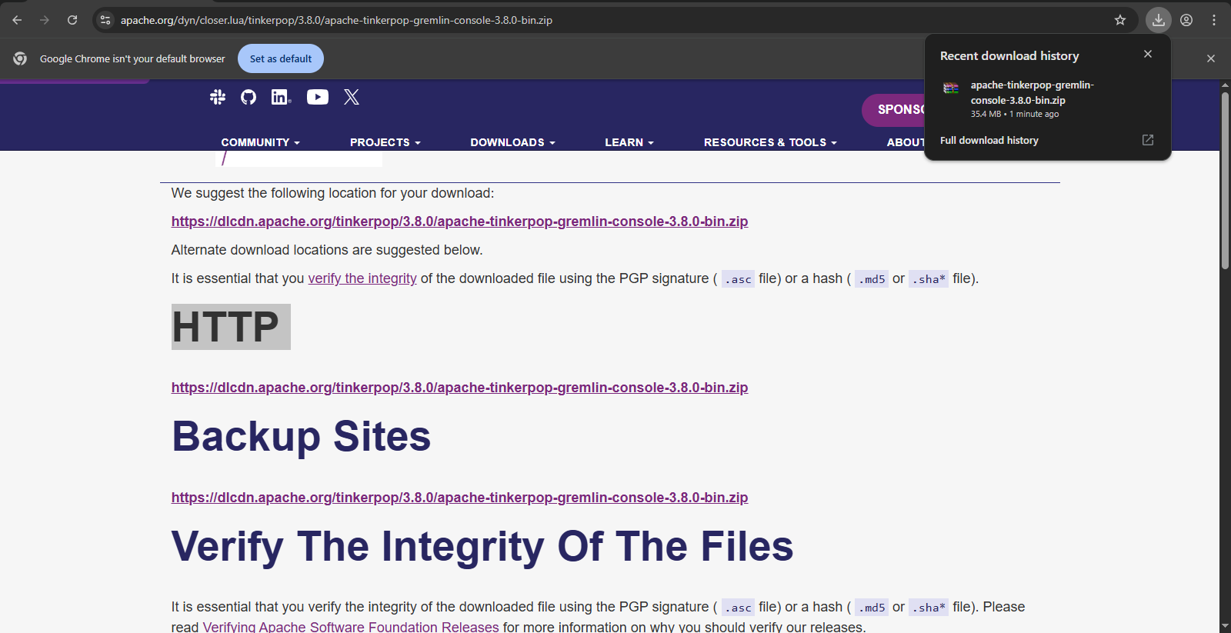
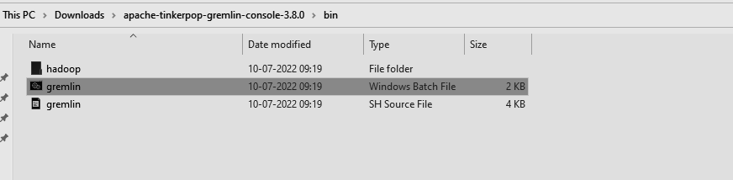
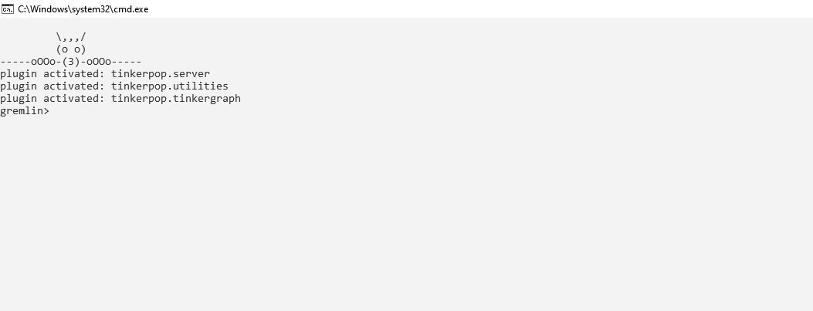

STEP 1: Create an empty graph
graph = TinkerGraph.open()
What this means: Creates a new graph in memory , Nothing is stored on disk , Temporary graph for learning.
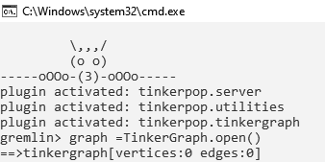
g = traversal().withEmbedded(graph)
What this means: g is a graph traversal object , All queries will be written using g
Think of g as:
“Remote control for the graph”

STEP 2: Add a PERSON node
v1 = g.addV('person').property('name','marko').property('age',29).next()
What is happening:addV('person') → creates a vertex , Label = person
• Properties:name = marko , age = 29
This creates:
(marko : person, age=29)

STEP 3: Add a SOFTWARE node
v2 = g.addV('software').property('name','lop').property('lang','java').next()
What is happening: Creates another vertex , Label = software
• Properties: name = lop , language = java
This creates: (lop : software, lang=java)

STEP 4: Create a relationship (EDGE)
g.addE('created').from(v1).to(v2)
What is happening: addE('created') → edge name , Connects: from marko , to lop
Graph now looks like: (marko) ---- created ----> (lop)
This is the core of Semantic Web: Data + relationship + meaning

5.What does querying mean in graph?
Query 1: Find marko : g.V().has('name','marko')
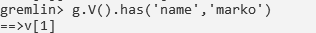
Breakdown:
• g.V() → all vertices
• has() → filter condition
• Finds node where name = marko

Query 2: What did marko create?
g.V().has('name','marko').out('created')
Breakdown:
• Start at marko
• Follow outgoing edge named created
• Reach software node
This replaces SQL JOIN

Query 3: Get software name
g.V().has('name','marko').out('created').values('name')
Output:
lop
6.Why do we use TinkerFactory.createModern()?
graph = TinkerFactory.createModern()
What this does:
• Loads a predefined graph
• Contains: multiple people , multiple software , multiple relationships
Used to practice complex queries without creating everything manually.
Example Query:
g.V().has('person','name',within('marko','vadas')).values('age')
What this means: Select multiple persons , Extract their ages , Demonstrates semantic filtering

Conclusion
In this experiment, we successfully explored the fundamentals of the Semantic Web by implementing a graph-based data model using the Apache TinkerPop framework. Unlike traditional relational databases that store data in tables, we utilized a Graph Database approach where data is stored as Vertices (Nodes) representing entities (e.g., people, software) and Edges representing the meaningful relationships between them (e.g., "created," "knows").

